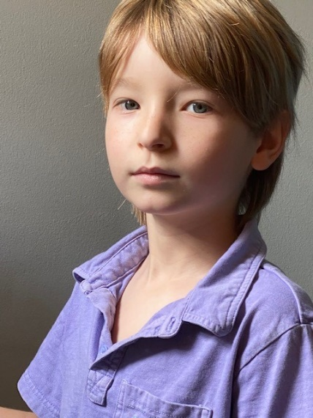
Yair Keydar

Additional Attributes: D.O.B
Height: 4’ 3” Eyes: Navy Blue 03/18/2013
Weight: 64lbs Hair: Dark Blonde

Special Skills and Hobbies
Singing, Reading, Good with animals, Outgoing, takes direction well, Respectful, Beginner tap dancing, very good with social media and technology, photography, has his own TikTok, ROBLOX and YouTube channel, friendly. _____________________________________________________________________________________
Experience
- August 2020 – Louisville KY virtual concert – Sharing the concert with his mom Cantor Magda Fishman.
- June 2020-CBST Gala NYC virtual concert- Duet: Somewhere Over the Rainbow.
- April 2020 – Virtual concert – Guest artist for the Cantors Assembly national organization.
- March 2020 Saint Gregory - Boca Raton FL - Interfaith concert - soloist: Grateful.
- May 2019 Donna Klein Jewish Academy, graduation – solo first grade.
- April 2019 Hamden CT – soloist: A Million Dreams.
- November 2018 At Beth El Stamford CT – interfaith concert – thanksgiving, new world chorus with friends, Cantors Magda Fishman Time to be grateful soloist with the choir.
- February 2018 – Florida – an evening of Love Songs - Yair guest artist- A Million Dreams.
- November 2017 at Beth Torah North Miami Beach, With Divas on the bimah - Somewhere Over the Rainbow.
- June 2017 - Divas on the Bimah, Beth El guest artist- Duet – Somewhere over the rainbow.
- November 2016 – Stamford CT- Union Baptist Church - A time to be grateful – interfaith event – Soloist - May there be peace
- Online videos: G-d bless America (with his mom – Cantor Magda Fishman), Somewhere over the Rainbow (duet), Halleluiah (Duet). ______________________________________________________________________________
Education and Awards
- Voice Coach – Badiene Magaziner
- Acting and Voice Over coach – Jody Prusan

